**COMMUNITY SERVICE PROJECT**

**A STUDY ON THE IMPACT OF INTERNET IN DABAGARDENS AREA OF VISAKHAPATNAM CITY**

*A project submitted in partial fulfilment of the requirements for the award of*

Bachelor of Computer Applications - Data Science

By

**ADIGARLA SARATH KUMAR**

**Reg. No. 2021-2222034**



Under the guidance of

Sri S.T.P.R. Kiran

Assistant Professor

Department of Computer Applications (UG)

Gayatri Vidya Parishad College for Degree and P.G. Courses (A)

Affiliated to Andhra University Visakhapatnam-45

2021-2024.

**GAYATRI VIDYA PARISHAD COLLEGE FOR DEGREE AND PG COURSES (A)**

**(Affiliated to Andhra University)**

**Rushikonda, Visakhapatnam-45**

Bachelor of Computer Applications – Data Science

**CERTIFICATE**

This is to certify that the project report titled **“A STUDY ON THE IMPACT OF INTERNET IN DABAGARDENS AREA OF VISAKHAPATNAM CITY” is the bonafied record of project work carried out by ADIGARLA SARATH KUMAR - 2021-2222034 are the students of this college, during the academic year 2021-2024, in partial fulfilment of the requirement for the award of the Bachelor of Computer Applications in Data Science.**

|  |  |  |
| --- | --- | --- |
| **Sri S. T. P. R. Kiran** | **Sri. P. Venkata Rao** | **Prof. I. S. Pallavi** |
| **Project Guide** | **Head of Department** | **Director of MCA** |
|  |  |  |

**External Examiner**

**CERTIFICATE**

It is certified that the project entitled **“A STUDY ON THE IMPACT OF INTERNET IN DABAGARDENS AREA OF VISAKHAPATNAM CITY**” being submitted by **ADIGARLA SARATH KUMAR - 2021-2222034** in partial fulfilment for the award of the **Bachelor of Computer Applications in Data Science** is a record of benefited work carried out under my guidance and supervision.

**Sri S.T.P.R. Kiran**

**Project Guide**

**Assistant Professor**

**DECLARATION**

I hereby declare that the dissertation entitled **A STUDY ON THE IMPACT OF INTERNET IN DABAGARDENS AREA OF VISAKHAPATNAM CITY** submitted for the bachelor’s degree is our original work and the dissertation has not formed the basis for the award of any degree, diploma or other similar title. Further, I state that this is an original piece of work which has not been published or submitted for publication in any magazine or journal.

**ADIGARLA SARATH KUMAR**

**Reg. No. 2021-2222034**

# ACKNOWLEDGEMENT

We were deeply indebted to Gayatri Vidya Parishad College for Degree and P.G. Courses (A), Visakhapatnam, affiliated to Andhra University for awarding Graduation to pursue our research on “**A STUDY ON THE IMPACT OF INTERNET IN DABAGARDENS AREA OF VISAKHAPATNAM CITY”** acknowledged by the Andhra University and authorities concerned.

We are thankful to ***Prof. S. Rajani, Principal,*** Gayatri Vidya Parishad College for Degree and P.G Courses (A) for support and encouragement in the completion of the project work.

We are also thankful to ***Prof. I.S. Pallavi, Director of MCA,*** Gayatri Vidya Parishad College for Degree and P.G Courses (A), for extending support in the completion the of study.

We are also thankful to ***Sri P. Venkatarao, Associate Professor & HOD of BCA,*** Gayatri Vidya Parishad College for Degree and P.G Courses (A), for suggestions and encouragement.

Our sincere thanks to our project guide ***Sri S.T.P.R. Kiran, Assistant Professor,*** Gayatri Vidya Parishad College for Degree and P.G Courses (A), for her support and valuable suggestions for the completion of the project.

We are also thankful to the college authorities, all the teaching staff and non-teaching staff of Gayatri Vidya Parishad College for Degree and P.G. Courses (A) who have been a constant source of support and encouragement during the study tenure.

We are thankful to all the selected sample respondents whose cooperation is needed in the collection of primary data. We especially thank one and all who have directly and indirectly contributed to the making of this project.

### CONTENTS

### Pg. No

1. **Introduction** 
   1. Knowledge Hub 2
   2. Effect on Children 2
   3. Impact on Various Age Groups 3
   4. Stress 4
   5. Distraction on People’s Lives 5
   6. Health 5
2. **Procedure**

2.1. Questionnaire 7

1. **Data Collection**

3.1. Data 8

3.2. Sample Data 9

**4) Objective Of the Study** 14

1. **Expected Outcomes**

5.1. Benefits of Community Service Project to Students 15

5.2. Learning Outcomes 15

5.3. Personal Outcomes 15

5.4. Social Outcomes 15

5.5. Career Development 15

5.6. Relationship With the Institution 16

5.7. Benefits Of Community Service Project to Faculty Members 16

1. **Analysis of Data**

6.1. Age Wise Collected Data 18

6.2. Internet Distraction Collected Data 18

6.3. Health Wise Collected Data 19

6.4. Usage Collected Data 19

6.5. Hours Daily Collected Data 20

6.6. Stress Collected Data 20

1. **Summary** 21
2. **Conclusion** 22

# ABSTRACT

The internet has revolutionized the way people live, work, and interact, leaving an indelible impact on every aspect of modern life. One of the most profound changes brought about by the internet is the way we communicate. With the advent of social media platforms, instant messaging, and video conferencing, the world has become a global village, connecting people across continents in real-time. This interconnectedness has fostered a sense of global community, allowing individuals to share ideas, cultures, and experiences like never before. However, this newfound connectivity has also raised concerns about privacy, cyberbullying, and the spread of misinformation, challenging society to navigate the ethical implications of the digital age.

# INTRODUCTION

* 1. **Knowledge Hub**

The Internet's role as a knowledge hub has not only made information readily available but has also transformed the way we learn. Online platforms offer a diverse range of learning materials, from video tutorials to interactive simulations, catering to various learning styles. The convenience of accessing educational content anytime, anywhere has empowered individuals to pursue self-directed learning and skill development. Furthermore, the Internet has facilitated global collaboration among researchers, educators, and students, breaking down geographical barriers and fostering a sense of interconnectedness in the academic world.

In the digital age, knowledge is at our fingertips. The Internet has democratized information, making it accessible to people of all backgrounds and ages. Educational websites and online courses have become virtual classrooms, allowing learners to acquire new skills and expertise from the comfort of their homes. E-books and academic journals, once confined to libraries, can now be downloaded with a click. This accessibility has ignited a thirst for continuous learning, enabling individuals to expand their horizons and stay informed about the latest developments in their fields.

Moreover, the Internet's capacity for knowledge sharing is unparalleled. Forums, social media, and collaborative platforms serve as hubs for discussions, debates, and the exchange of ideas. People from different corners of the world can connect, learn from each other, and contribute to the global pool of knowledge. This unprecedented level of connectivity has not only fostered intellectual growth but has also promoted cross-cultural understanding and cooperation.

* 1. **Effect on Children**

While the positive aspects of the Internet for children are substantial, it's essential to recognize the challenges it poses. Cyberbullying, for instance, can have severe emotional and psychological consequences for young individuals. Parents and educators need to be vigilant in guiding children's online experiences, emphasizing digital literacy and responsible internet use. Additionally, the addictive nature of online activities demands a balanced approach to screen time, encouraging physical activity and face-to-face interactions to ensure children's overall well-being.

The Internet has become an integral part of a child's upbringing, offering a wealth of opportunities for learning and socialization. Educational websites engage young minds with interactive lessons and educational games that make learning enjoyable. Online communities provide platforms for children to explore their interests and passions while connecting with like-minded peers from around the world. Moreover, during times of physical isolation, the Internet has served as a lifeline, allowing children to maintain vital social connections with friends and family.

However, the digital landscape is not without its perils. The unrestricted access to the Internet can expose children to harmful content, from violent imagery to inappropriate material. The rise of cyberbullying poses a significant threat to their mental well-being. Moreover, the allure of digital devices can lead to excessive screen time, which has been linked to various health issues, including obesity and sleep disturbances. Internet addiction, characterized by a compulsive need to be online, is a growing concern that demands attention from parents, educators, and healthcare professionals.

* 1. **Impact on Various Age Groups**

For adolescents and teenagers, the Internet serves as a platform for self-expression and identity development. However, the exposure to online risks necessitates education on digital safety and privacy. Young adults and professionals, on the other hand, rely on the Internet for career development and networking. The ability to access vast amounts of information instantly has become a crucial asset in their personal and professional lives. For seniors, the Internet has opened doors to lifelong learning, social connections, and access to healthcare resources, promoting active aging and mental well-being.

In the realm of education, the Internet has revolutionized the way different age groups acquire knowledge. Young children, with their sponge-like minds, benefit from engaging educational apps and websites that facilitate cognitive development. Adolescents and teenagers find a virtual space for social interactions, entertainment, and educational exploration. This access to information and connectivity enhances their development but also exposes them to risks, such as cyberbullying and exposure to inappropriate content.

Young adults and professionals have integrated the Internet into their daily lives seamlessly. From online courses that enable career advancement to the convenience of remote work, the Internet has become an indispensable tool for personal and professional growth. The ability to connect with colleagues and peers worldwide fosters collaboration and innovation. However, it also brings challenges, such as the pressure to constantly stay connected and the blurring of work-life boundaries.

For seniors, the Internet can be a bridge to staying connected with loved ones, even when physical distance separates them. Video calls, social media, and email enable seniors to maintain their social networks and combat feelings of isolation. Moreover, the Internet serves as a valuable resource for health information, enabling seniors to research medical conditions and access telemedicine services. It also offers opportunities for lifelong learning, allowing seniors to explore new interests and hobbies from the comfort of their homes.

* 1. **Stress**

The phenomenon of digital stress or technostress is a consequence of our hyper-connected digital lives. The relentless influx of information and the constant need for responsiveness can lead to burnout and decreased mental resilience. Strategies for managing digital stress include setting boundaries on device use, practicing mindfulness, and fostering a healthy offline balance. Recognizing the signs of digital stress is essential to mitigate its impact and maintain mental health.

In our fast-paced digital world, the pressure to be always connected can take a toll on our mental well-being. "Digital stress" or "technostress" has emerged as a common affliction, driven by the constant stream of emails, notifications, and the expectation of immediate responses. Social media platforms, while providing avenues for social connection, can also foster feelings of comparison, envy, and the fear of missing out (FOMO).

To combat digital stress, individuals must proactively manage their online engagement. Setting boundaries, such as designated "offline" hours, can help create a healthy balance between digital and real-life interactions. Mindfulness practices can assist in reducing the anxiety associated with constant connectivity. Additionally, employers and organizations are recognizing the importance of promoting digital well-being by encouraging employees to disconnect during non-working hours, ultimately fostering a healthier work-life balance.

* 1. **Distraction on People’s Lives**

The Internet's role as a source of distraction is particularly evident in the workplace and educational settings. Online distractions can lead to decreased productivity and hinder students' ability to focus on their studies. Employers and educators are increasingly implementing strategies to manage digital distractions, such as using productivity tools and promoting time management skills. Learning to navigate the digital landscape while maintaining focus is a vital skill in the modern age.

While the Internet offers a treasure trove of information, it also presents a myriad of distractions. In educational settings, students often grapple with the temptation of social media, online games, and endless entertainment options. The allure of these distractions can lead to reduced focus, lower academic performance, and a challenge for educators to keep students engaged.

In the workplace, the battle against digital distractions is equally significant. The constant influx of emails, instant messages, and the allure of browsing the web can derail productivity and impede progress on important tasks. Employers are implementing strategies to combat these distractions, from using website blockers to encouraging time management techniques.

* 1. **Health**

The Internet's impact on people's lives has been significant, particularly concerning health-related aspects. On one hand, the Internet has democratized health information, making it easily accessible to the public. People can now research symptoms, seek medical advice, and access valuable health resources online. Telemedicine and health apps have improved healthcare accessibility, especially in remote areas. Additionally, online support communities provide valuable emotional support and camaraderie for individuals dealing with health challenges. However, the Internet also poses health risks, particularly when it comes to mental health. Social media's influence can contribute to feelings of inadequacy, anxiety, and depression. Moreover, excessive screen time and sedentary behaviors associated with internet usage have raised concerns about physical health, such as obesity and musculoskeletal problems.

# PROCEDURE

As a student of Gayatri Vidya Parishad College for Degree and PG Courses(A) 3rd year of BCA-DATA SCIENCE has gathered some questions of social immersion project on "Impact of Internet" After a period of preliminary trials of various methods, the final data were collected. It should be kept in mind that the results describe the various habits of people regarding internet of different age groups. The material was collected from the residents of Visakhapatnam, Andhra Pradesh. It has been involved of people from various age groups consisting of both male and female.

The students, trained and carefully supervised by a member of the immersion project, interviewed approximately 50 people in our locality, and 60 of students aged between 10 to 29.

Each student talked alternately with people from different groups so that no constant error due to the student’s personality or increasing routine would affect the results. A total of 180 people were interviewed, with approximately 30 in each of the group. The survey lasted from 5 to 15 minutes to each person.

# 2.1 Questionnaire

**Gayatri Vidya Parishad College for Degree and P.G. Courses (A)**

**Rushikonda, Visakhapatnam-45**

**Department of Computer Applications**

**Social Immersion Project**

**Topic:** The Impact of Internet in a Day-to-Day Activity

Name: Age: Gender:

1. Do you use daily internet?
2. What do you use Internet for?
3. Has Internet changed the way of your life?
4. What is your opinion on Internet as a knowledge hub?
5. Does Internet distract you while you are into serious study/ work?
6. What is your opinion on children using internet?
7. How many hours do you spend on internet daily?
8. Did you learn or master any new art with the help of internet? Y/N
9. Does Senior citizens in your house use internet daily?
10. Do you think children are wasting their time due to internet?
11. Internet affects the IQ level and education of children. True/false
12. Do you turn on your internet soon after waking up daily?
13. Did you face or experience any health issues owing to internet usage?
14. Does internet usage make you stressful?
15. Does Internet help you in your academics?

# DATA COLLECTION

# Data

# Data refers to information, facts, or pieces of knowledge stored and processed by computers, which can be analyzed and used to make decisions or support decision-making. It can be in various forms, such as text, images, audio, or numerical values, and can be structured or unstructured. Effective management and analysis of data are crucial for businesses, governments, and individuals to improve decision-making and drive growth. Data is information stored and processed by computers and used to support decision-making and analysis. It can be in various forms, such as text, images, audio, or numerical values, and can be structured or unstructured. Effective management and analysis of data are important for businesses, governments, and individuals to drive growth and improve decision-making.

Data can be analysed in various ways, including:

* Descriptive statistics: summarize and describe the main features of a data set, such as mean, median, and mode.
* Inferential statistics: make inferences about a population based on a sample of data, such as hypothesis testing.
* Predictive modelling uses statistical or machine learning techniques to predict future events based on historical data.
* Data visualization: represent data in graphical forms, such as charts, graphs, and maps, to help identify patterns and trends.
* Machine learning uses algorithms to learn from data, identify patterns and relationships, and make predictions or decisions.
* Text analysis: process and analyse large amounts of unstructured text data to extract insights and meaning.

**3.2 Sample Data**

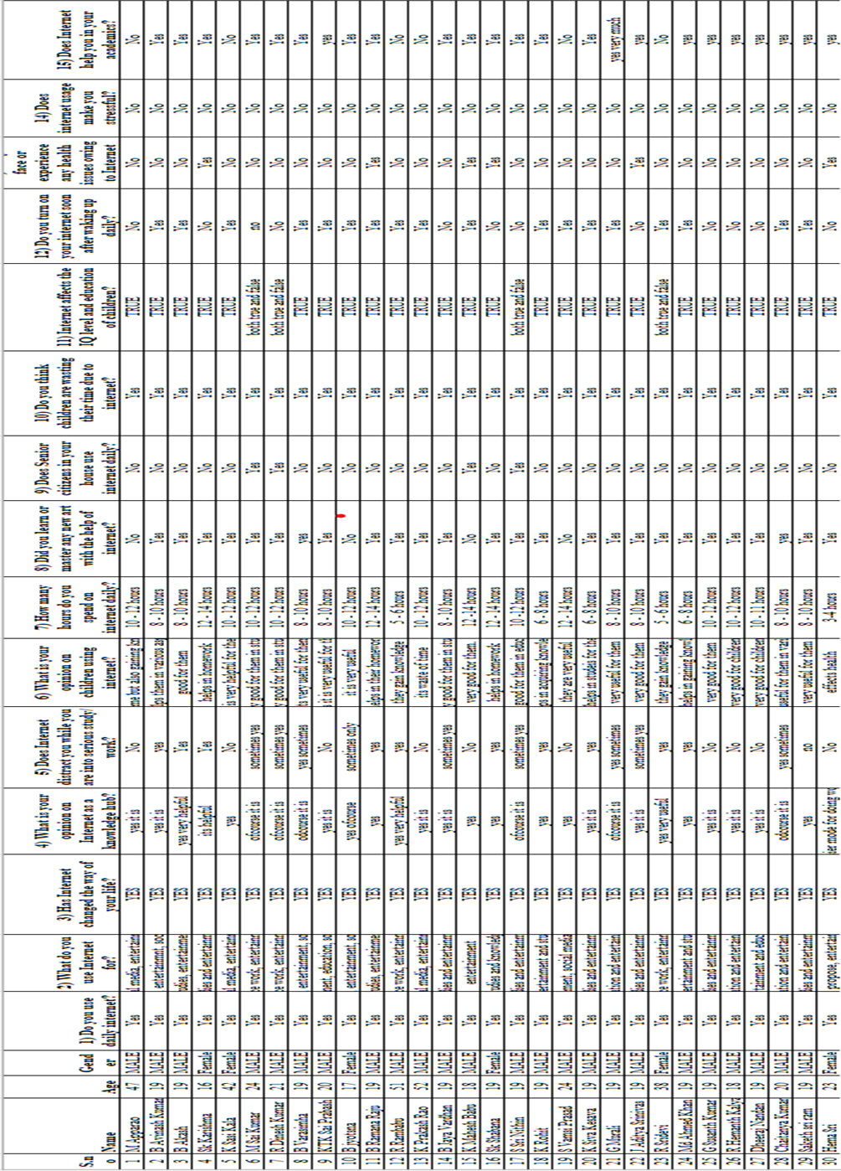

***Table-3.1 Showing Data of 1 – 30 Records***

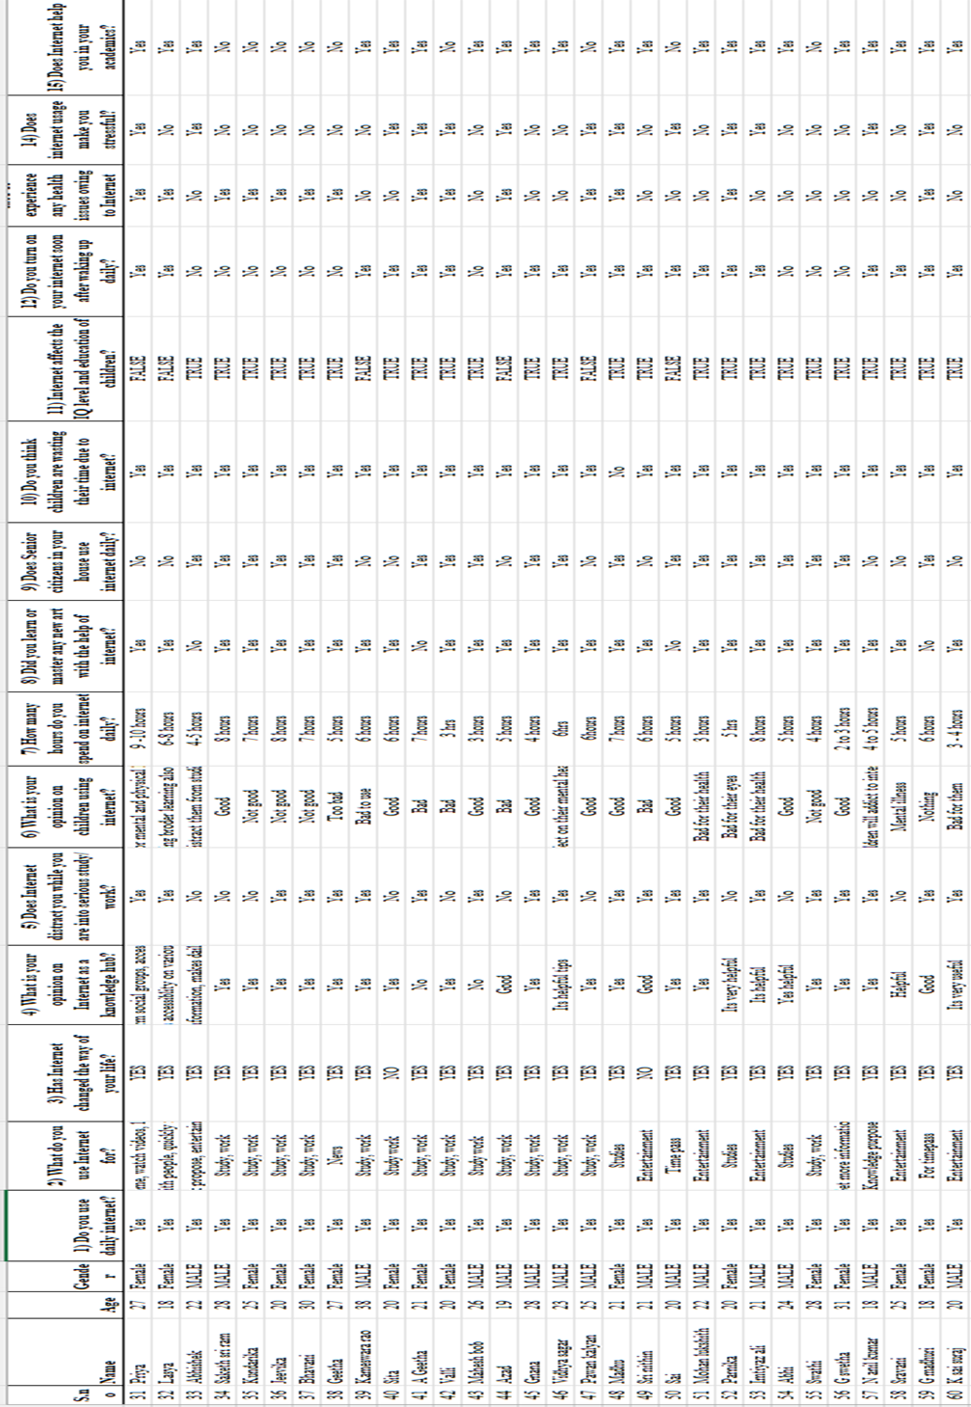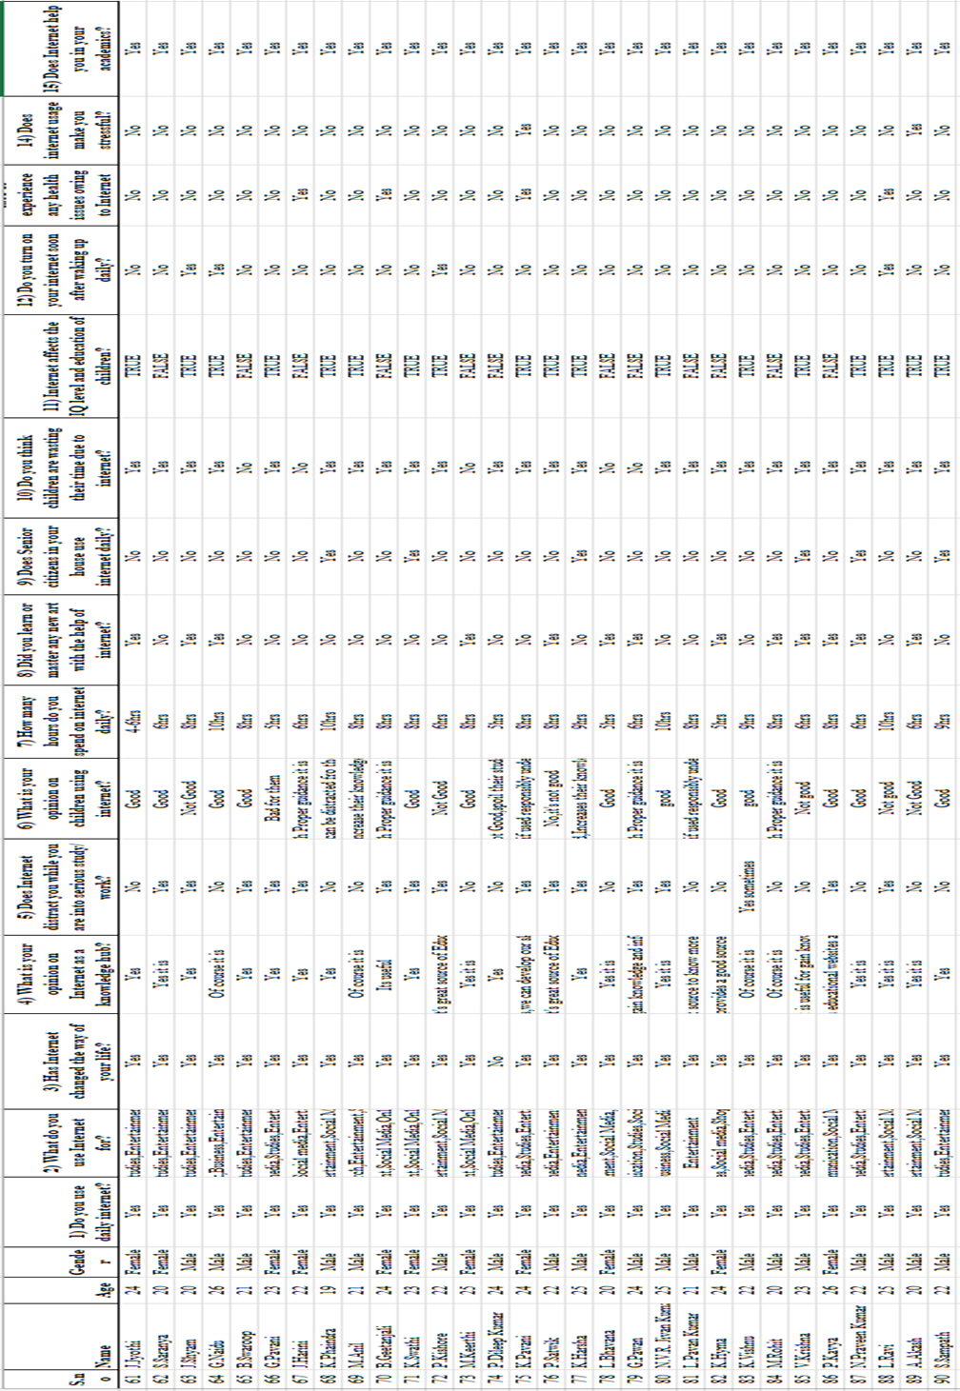

***Table-3.2 Showing Data of 31 – 60 Records***

***Records***

***Table-3.3 Showing Data of 61 – 90 Records***

***Records***

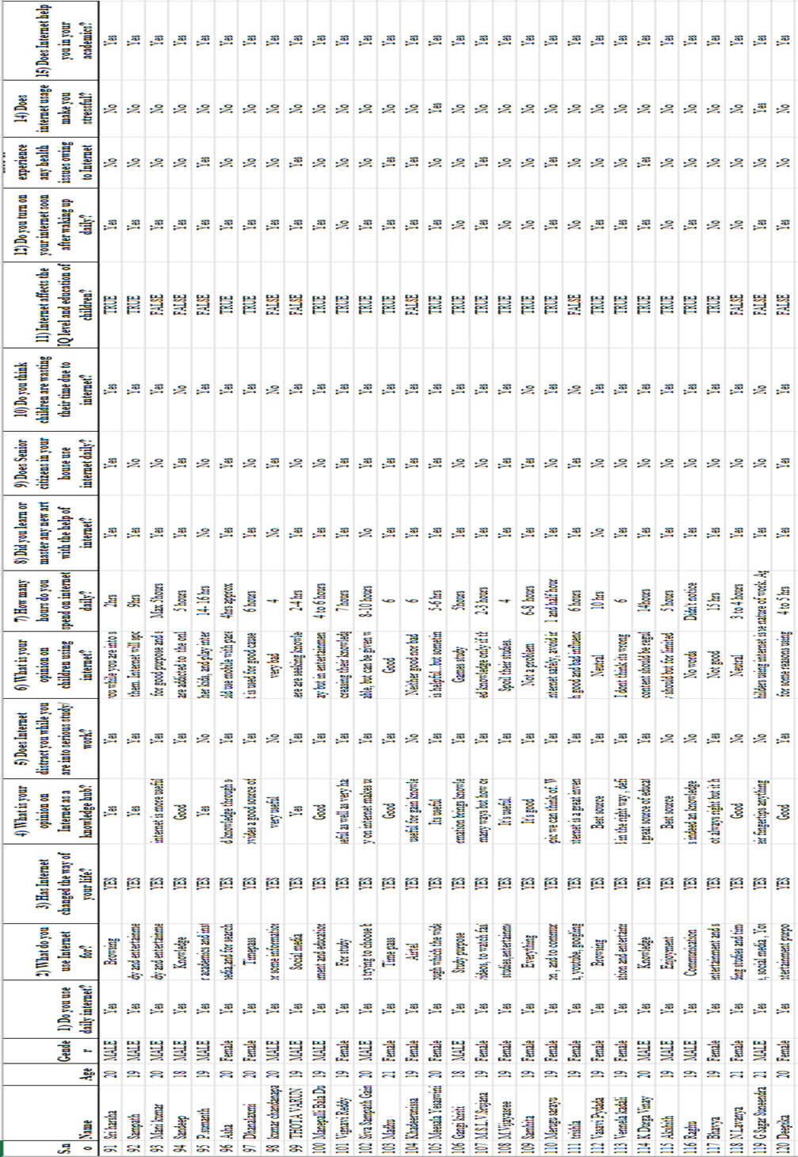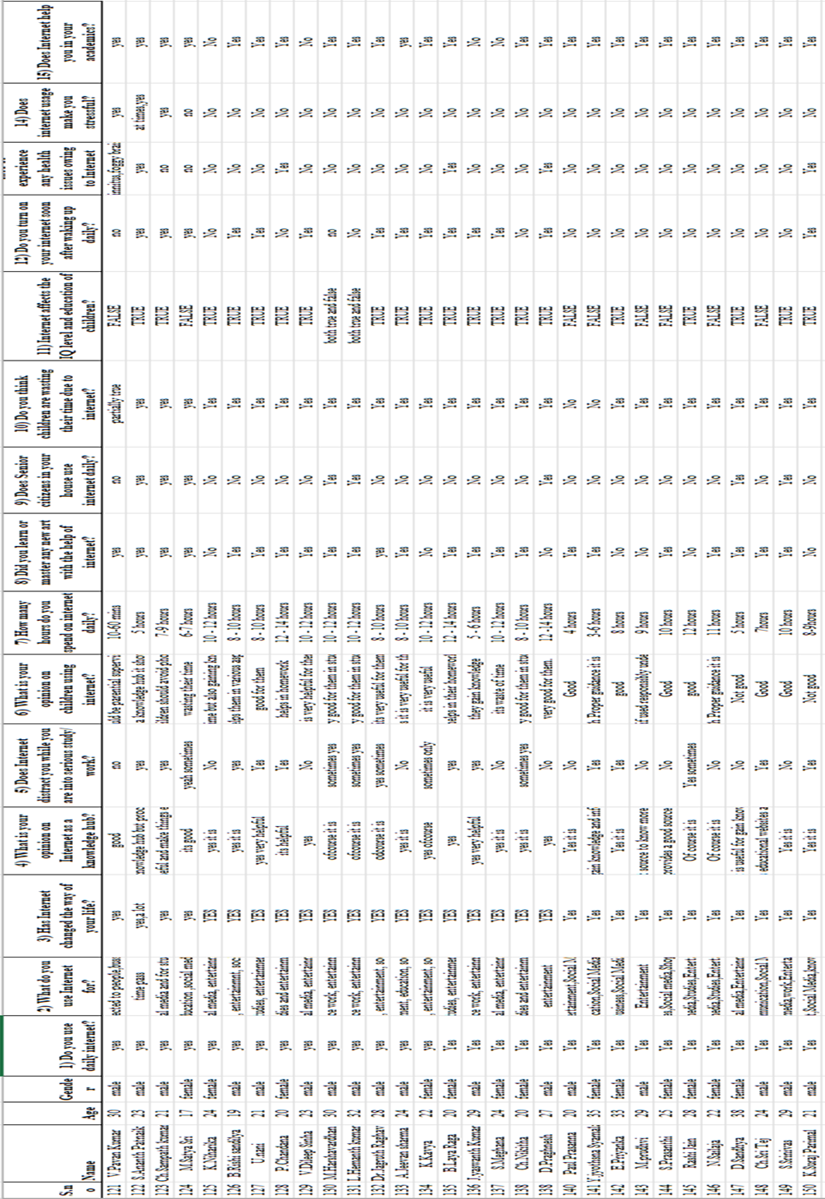

***Table-3.4 Showing Data of 91 – 120 Records***

***Records***

***Table-3.5 Showing Data of 121 – 150 Records***

***Records***

# 4. OBJECTIVE OF THE STUDY

Community Service Project has the specific objectives are,

* To sensitize the students to the living conditions of the people who are around them.
* To help students to realize the stark realities of the society.
* To bring about an attitudinal change in the students and help them to develop societal consciousness, sensibility, responsibility and accountability.
* To make students aware of their inner strength and help them to find new/out of box solutions to the social problems.
* To make students socially responsible citizens who are sensitive to the needs of the disadvantaged sections.
* To help students to initiate developmental activities in the community in coordination with public and government authorities.
* To develop a holistic life perspective among the students by making them study culture, traditions, habits, lifestyles, resource utilization, wastages and its management, social problems, public administration system and the roles and responsibilities of different persons across different social systems.

# 5. EXPECTED OUTCOMES

* 1. **Benefits of Community Service Project to Students**

A group of students assigned from Visakhapatnam District. Firstly, this group of students conducted survey and interacted with the people and conducted awareness rallies in the area.

Secondly, the students take up a project work related to Women Health.

* 1. **Learning Outcomes**
* Positive impact on students' academic learning.
* Improves students' ability to apply what they have learned in the real world " Positive impact on academic outcomes such as demonstrated complexity of understanding, problem analysis, problem-solving, critical thinking, and cognitive development.
* Improved ability to understand complexity and ambiguity.
  1. **Personal Outcomes**
* Greater sense of personal efficacy, personal identity, spiritual growth, and moral development.
* Greater interpersonal development, particularly the ability to work well with others, and build leadership and communication skills.
  1. **Social** **Outcomes**
* Reduced stereotypes and greater inter-cultural understanding.
* Improved social responsibility and citizenship skills.
* Greater involvement in community service after graduation.
  1. **Career** **Development**
* Connections with professionals and community members for learning and career opportunities.
* Greater academic learning, leadership skills, and personal efficacy can lead to greater opportunity.
  1. **Relationship with the Institution**
* Stronger relationships with faculty.
* Greater satisfaction with college.
* Improved graduation rates.
  1. **Benefits** **of** **Community** **Service** **Project** **to** **Faculty** **Members**
* Satisfaction with the quality of student learning.
* New avenues for research and publication via new relationships between faculty and community.
* Providing networking opportunities with engaged faculty in other disciplines or institutions.
* A stronger commitment to one's research.

# ANALYSIS OF DATA

I have been assigned project in Visakhapatnam District. Firstly, I have conducted survey and interacted with the people of their residents and conducted awareness rallies.

Secondly, I have taken up a project work related to the Impact of Internet.

In this survey I have interacted with the people and known about their daily routine of their usage of internet and found how the people of the area are aware of healthy habits of internet usage, healthy online habits and safety precautions when online. I have collected data from the people regarding their daily habits of internet and for which purposes they use internet for.

* Number of people were surveyed -150
* Number of people who use internet daily – 150.
* Number of people who belong in the age group (10 – 20) – 70.
* Number of people who belong in the age group (20 – 40) – 71.
* Number of people who belong in the age group (40 – 60) – 9.
* Number of Males –89
* Number of Females – 61
  1. **Age Wise Collected Data**

We have collected the data of 150 people from different areas by asking them their age. The following graph shows the age distribution of the people.

* 1. **Internet Distraction Collected Data**

We have collected the data of 150 people from different areas by asking them if they get distracted during work by internet. The following graph shows whether the people agree or not.

* 1. **Health Wise Collected Data**

We have collected the data of 150 people from different areas by asking them if they faced any health issues due to internet. The following graph shows whether the people agree or not.

* 1. **Usage Collected Data**

We have collected the data of 150 people from different areas by asking them what do they use internet for. The following graph shows the various purposes for which people use internet.

* 1. **Hours Daily Collected Data**

We have collected the data of 150 people from different areas by asking them how many hours they use internet for. The following graph shows the no. of hours for which people use internet.

* 1. **Stress Collected Data**

We have collected the data of 150 people from different areas by asking them do they feel stressed while using internet. The following graph shows whether the people agree or not.

1. **SUMMARY**

# 

# The data collected from various individuals provides a clear picture of the significant impact of the internet on daily lives. Nearly everyone utilizes the internet on a daily basis, with the majority falling within the age group of 10 to 20 years old. The average usage time is around 6 hours or more, primarily for studying, social media, and entertainment. Despite the internet being considered a knowledge hub and a platform for acquiring new skills, a majority of people express concerns about children wasting their time online, leading to opposition against children using the internet extensively. The survey also reveals that distractions caused by the internet during work are slightly higher than those who remain undistracted. Surprisingly, most individuals haven't experienced any major health issues or stress related to internet usage.

1. **CONCLUSION**

From the data we collected from the people has given a very clear picture that almost everyone is using internet daily and the majority of them belong to the age group of 10 – 20. Most of the people use internet daily for an average of 6 hours or above. People mainly use it for studying, social media, entertainment. Majority of the people think that children are wasting their time using internet and are against children using internet. Many people agree that Internet is a knowledge hub and have learnt at least one skill online. The people who are distracted by internet during work are slightly higher than the people who don’t get distracted. Majority of the people didn’t face any health issues while using Internet and don’t feel stressed while using it.